Functional Requirements Document (FRD)
Project: OptimAlze Buddy - AI-Powered Government Services Agent
Version: 1.0
Prepared for: OptimAlze Development Team & Government Stakeholders
Table of Contents
- Introduction
1.1. Purpose
1.2. Scope
1.3. Definitions, Acronyms, and Abbreviations
1.4. References
1.5. Document Overview
- Overall Description
2.1. Product Perspective
2.2. Product Functions (High-Level)
2.3. User Classes and Characteristics
2.4. Operating Environment
2.5. Design and Implementation Constraints
2.6. Assumptions and Dependencies
- System Architecture
3.1. High-Level Architectural Overview
3.2. Component Diagram
3.3. Data Flow Diagram
3.4. Use Case Diagram
- Functional Requirements
4.1. Module 1: Conversational Interface & User Experience
4.2. Module 2: RAG-Based Information Retrieval System
4.3. Module 3: Task Automation & Agentic Workflows
4.4. Module 4: Document Intelligence & Validation
4.5. Module 5: Integration with Government Systems
4.6. Module 6: Administration & Compliance
4.7. Module 7: Security & Audit
- Non-Functional Requirements
5.1. Performance Requirements
5.2. Security Requirements
5.3. Usability Requirements
5.4. Reliability & Availability
5.5. Scalability & Maintainability
5.6. Compliance Requirements
- Data Requirements
6.1. Data Input Specifications
6.2. Output Data Structure
6.3. Data Storage & Retention
6.4. Data Privacy & Protection
- External Interface Requirements
7.1. User Interfaces
7.2. Hardware Interfaces
7.3. Software Interfaces
7.4. Communication Interfaces
- Appendices
Appendix A: PlantUML Diagrams - Source Code
Appendix B: Government Service Categories
Appendix C: Document Validation Standards
Appendix D: Revision History

1. Introduction
1.1. Purpose
This Functional Requirements Document (FRD) defines the comprehensive specifications for the OptimAlze Buddy system—an AI-powered digital services agent designed to transform citizen-government interactions. The document establishes the functional capabilities, system behaviors, and technical interfaces required to deliver accurate, secure, and efficient public service automation through conversational AI.
1.2. Scope
The OptimAlze Buddy system provides a unified conversational interface for accessing and executing government and municipal services. The scope includes:
In-Scope:
- Conversational interface supporting text and voice interactions
- RAG-based information retrieval from government policy documents and service catalogs
- Automated task execution (appointment booking, form submissions, application initiation)
- Real-time document validation and quality checking
- Multi-channel deployment (web, mobile, social media, SMS)
- Integration with existing government service portals and back-office systems
- Multi-language support for citizen interactions
- Compliance with government security and data protection standards
Out-of-Scope:
- Physical service delivery (requires human intervention)
- Legal decision-making or adjudication
- Payment processing integration (handled via existing systems)
- Creation of new government policies or regulations
- Hardware infrastructure provisioning
1.3. Definitions, Acronyms, and Abbreviations
Table: Terminology Definitions
Term | Definition
RAG | Retrieval-Augmented Generation. AI technique combining information retrieval with generative AI for accurate, grounded responses.
Agentic Workflow | Automated sequence of actions executed by AI based on user intent and system capabilities.
OCR | Optical Character Recognition. Technology for extracting text from images and documents.
NLP | Natural Language Processing. AI capability to understand and generate human language.
API | Application Programming Interface.
SLA | Service Level Agreement.
SLA | Service Level Agreement.
GDPR | General Data Protection Regulation (EU).
PII | Personally Identifiable Information.
SSO | Single Sign-On.
CMS | Content Management System.
CRM | Citizen Relationship Management.
1.4. References
- Project Charter: OptimAlze Buddy Digital Transformation Initiative
- Government Digital Service Standards (Local Government Version 3.1)
- Data Protection Impact Assessment: Government AI Services
- Accessibility Guidelines: WCAG 2.1 AA Compliance
- Security Framework: Government Cloud Security Standards
1.5. Document Overview
This document systematically details the functional requirements of OptimAlze Buddy, organized by architectural components and user workflows. It provides the foundation for system design, development, testing, and deployment across municipal environments.

2. Overall Description
2.1. Product Perspective
OptimAlze Buddy serves as a digital intermediary between citizens and government services, integrating with existing municipal systems while providing a modern, AI-powered interface. The system operates within the government's digital ecosystem, enhancing rather than replacing existing service delivery channels.
2.2. Product Functions (High-Level Summary)
- Understand citizen queries in natural language across multiple channels
- Retrieve accurate information from authoritative government sources using RAG
- Execute service workflows (appointments, form submissions, applications)
- Validate uploaded documents in real-time for completeness and quality
- Guide citizens through complex processes with step-by-step assistance
- Integrate with backend government systems for data exchange and service fulfillment
- Learn from interactions to improve accuracy and service coverage
- Report on service usage, citizen satisfaction, and system performance
- Comply with government security, privacy, and accessibility standards
2.3. User Classes and Characteristics
Table: User Classes and Requirements
User Class | Characteristics & Key Requirements
Citizen | Primary user. Needs simple, accessible service access. Requires clear guidance, minimal technical expertise. May have varying digital literacy.
Government Staff | Uses system for monitoring, exception handling, and complex cases. Needs override capabilities, audit trails, and integration with case management systems.
System Administrator | Manages system configuration, service catalogs, user permissions, and monitors system health. Requires comprehensive management tools.
Content Manager | Maintains knowledge base, updates service information, manages policy documents. Needs intuitive content management interface.
IT Security Officer | Ensures compliance with government security standards. Requires security monitoring, audit logging, and compliance reporting.
2.4. Operating Environment
Software Environment:
- Cloud-native deployment on government-approved cloud infrastructure
- Containerized microservices architecture (Docker/Kubernetes)
- AI/ML stack: Python-based with RAG implementation, document intelligence libraries
- Frontend: Responsive web application with progressive web app capabilities
- Integration: RESTful APIs, SOAP web services for legacy systems
- Databases: PostgreSQL for structured data, vector database for embeddings, document storage
Hardware Environment:
- Server-side: Government cloud infrastructure with dedicated GPU capacity for AI processing
- Client-side: Accessible via standard web browsers, mobile devices, and existing government portals
- Network: Must operate within government security perimeters and firewalls
2.5. Design and Implementation Constraints
- Must comply with government security classification standards (up to "Official" level)
- Must support at least 3 official languages of the implementing region
- Must maintain 99.5% uptime during official service hours
- Must integrate with at least 5 existing government service platforms in initial deployment
- Must provide full audit trail for all citizen interactions and system actions
- Must be accessible to users with disabilities (WCAG 2.1 AA compliance)
- Must support offline functionality for essential services during connectivity issues
2.6. Assumptions and Dependencies
Assumptions:
- Government service information is available in digital, structured formats
- Existing government systems have API or integration capabilities
- Citizens have basic access to digital devices and internet connectivity
- Government staff are available for handling exceptions and complex cases
- Legal framework permits AI-assisted service delivery
Dependencies:
- Availability of government service catalogs and policy documents in machine-readable formats
- Existing authentication systems (government ID, SSO) for secure access
- Government network infrastructure supporting required integrations
- Regular updates to service information and policy changes
- Training data for AI models specific to government domain language

3. System Architecture
3.1. High-Level Architectural Overview
The system employs a layered microservices architecture with clear separation between presentation, application, AI, and data layers. Key architectural principles include security-by-design, scalability, and maintainability.
3.2. Component Diagram
3.3. Data Flow Diagram
3.4. Use Case Diagram

4. Functional Requirements
4.1. Module 1: Conversational Interface & User Experience
Table: Conversational Interface Requirements
Req. ID | Requirement Description | Priority
FR-1.1 | The system shall support text-based conversations via web chat interface with typing indicators and read receipts. | Must Have
FR-1.2 | The system shall support voice interactions including speech-to-text and text-to-speech conversion. | Must Have
FR-1.3 | The interface shall be available 24/7 with clear indication of service hours for human escalation. | Must Have
FR-1.4 | The system shall support multiple languages with automatic detection and manual selection. | Must Have
FR-1.5 | The interface shall provide conversation history accessible to authenticated users. | Must Have
FR-1.6 | The system shall offer suggested responses and quick-reply buttons for common queries. | Should Have
FR-1.7 | The interface shall be fully accessible with screen reader support, keyboard navigation, and high-contrast mode. | Must Have
FR-1.8 | The system shall provide real-time typing assistance for form completion. | Should Have
FR-1.9 | The interface shall support file upload through drag-and-drop and file browser. | Must Have
FR-1.10 | The system shall display processing status indicators during document validation and task execution. | Must Have
4.2. Module 2: RAG-Based Information Retrieval System
Table: Information Retrieval Requirements
Req. ID | Requirement Description | Priority
FR-2.1 | The system shall ingest and index government policy documents, service guidelines, and FAQ content. | Must Have
FR-2.2 | The RAG system shall provide citations to source documents for all information provided. | Must Have
FR-2.3 | The system shall maintain a confidence score for each retrieved answer and disclose low-confidence responses. | Must Have
FR-2.4 | The retrieval system shall support semantic search across unstructured government documents. | Must Have
FR-2.5 | The system shall update the knowledge base automatically when source documents are updated. | Should Have
FR-2.6 | The RAG pipeline shall filter out-of-date information based on document versioning. | Must Have
FR-2.7 | The system shall maintain separate knowledge bases for different government departments. | Must Have
FR-2.8 | The retrieval system shall handle ambiguous queries by asking clarifying questions. | Should Have
FR-2.9 | The system shall log all information retrieval requests for accuracy monitoring. | Must Have
FR-2.10 | The RAG system shall achieve at least 95% accuracy on factual government service questions. | Must Have
4.3. Module 3: Task Automation & Agentic Workflows
Table: Task Automation Requirements
Req. ID | Requirement Description | Priority
FR-3.1 | The system shall identify user intent for task execution versus information requests. | Must Have
FR-3.2 | The system shall guide users through multi-step government processes with progress tracking. | Must Have
FR-3.3 | The system shall book appointments with government offices based on availability. | Must Have
FR-3.4 | The system shall pre-fill government forms with user profile information where authorized. | Must Have
FR-3.5 | The system shall submit completed applications to appropriate government systems. | Must Have
FR-3.6 | The system shall provide status updates for submitted applications. | Must Have
FR-3.7 | The system shall handle payment initiation through integration with government payment gateways. | Should Have
FR-3.8 | The system shall generate checklists for complex application processes. | Must Have
FR-3.9 | The system shall escalate to human agents when automation cannot complete a task. | Must Have
FR-3.10 | The system shall maintain transaction state across sessions for long-running processes. | Must Have
4.4. Module 4: Document Intelligence & Validation
Table: Document Validation Requirements
Req. ID | Requirement Description | Priority
FR-4.1 | The system shall validate uploaded document formats (PDF, JPG, PNG, DOC). | Must Have
FR-4.2 | The system shall perform OCR on uploaded documents to extract text content. | Must Have
FR-4.3 | The system shall check document image quality (resolution, glare, blur). | Must Have
FR-4.4 | The system shall validate document completeness against required fields. | Must Have
FR-4.5 | The system shall verify document authenticity indicators (signatures, stamps, watermarks). | Should Have
FR-4.6 | The system shall detect and flag potential document tampering. | Could Have
FR-4.7 | The system shall provide real-time feedback on document issues with specific correction guidance. | Must Have
FR-4.8 | The system shall support batch upload and validation of multiple documents. | Should Have
FR-4.9 | The system shall maintain a library of acceptable document templates for comparison. | Must Have
FR-4.10 | The system shall achieve at least 90% accuracy in identifying document deficiencies. | Must Have
4.5. Module 5: Integration with Government Systems
Table: Integration Requirements
Req. ID | Requirement Description | Priority
FR-5.1 | The system shall integrate with government citizen databases for identity verification. | Must Have
FR-5.2 | The system shall connect to appointment scheduling systems of various departments. | Must Have
FR-5.3 | The system shall interface with case management systems for application tracking. | Must Have
FR-5.4 | The system shall support both synchronous (API) and asynchronous (message queue) integration patterns. | Must Have
FR-5.5 | The system shall implement retry logic and error handling for integration failures. | Must Have
FR-5.6 | The system shall maintain data mapping between conversational inputs and backend system fields. | Must Have
FR-5.7 | The system shall support legacy systems through adapters and middleware. | Should Have
FR-5.8 | The system shall implement proper authentication and authorization for all integrations. | Must Have
FR-5.9 | The system shall log all integration calls for debugging and audit purposes. | Must Have
FR-5.10 | The system shall maintain integration health monitoring and alerting. | Must Have
4.6. Module 6: Administration & Compliance
Table: Administration Requirements
Req. ID | Requirement Description | Priority
FR-6.1 | Administrators shall manage service catalog and availability schedules. | Must Have
FR-6.2 | The system shall provide role-based access control for different government staff roles. | Must Have
FR-6.3 | Administrators shall configure conversation flows and business rules. | Must Have
FR-6.4 | The system shall generate compliance reports for data protection regulations. | Must Have
FR-6.5 | Administrators shall review and approve AI responses before deployment to production. | Should Have
FR-6.6 | The system shall provide analytics dashboards for service usage and citizen satisfaction. | Must Have
FR-6.7 | Administrators shall manage escalation rules and human agent assignment. | Must Have
FR-6.8 | The system shall support A/B testing for conversation improvements. | Could Have
FR-6.9 | Administrators shall configure automated alerts for system issues. | Must Have
FR-6.10 | The system shall maintain version control for all configurations and knowledge base updates. | Must Have
4.7. Module 7: Security & Audit
Table: Security Requirements
Req. ID | Requirement Description | Priority
FR-7.1 | The system shall encrypt all citizen data both in transit and at rest. | Must Have
FR-7.2 | The system shall implement secure authentication with government ID integration. | Must Have
FR-7.3 | All AI model outputs shall be logged for bias monitoring and fairness auditing. | Must Have
FR-7.4 | The system shall maintain immutable audit logs of all user interactions. | Must Have
FR-7.5 | The system shall implement data minimization principles, collecting only necessary information. | Must Have
FR-7.6 | The system shall support data retention policies aligned with government regulations. | Must Have
FR-7.7 | The system shall conduct regular security vulnerability assessments. | Must Have
FR-7.8 | The system shall implement rate limiting and DDoS protection. | Must Have
FR-7.9 | The system shall provide secure data export for citizen right-to-access requests. | Must Have
FR-7.10 | The system shall undergo third-party security certification annually. | Must Have

5. Non-Functional Requirements
5.1. Performance Requirements
Table: Performance Metrics
Req. ID | Requirement Description | Metric
NFR-1.1 | The system shall respond to text queries within 2 seconds (95th percentile). | < 2 sec
NFR-1.2 | Document validation shall complete within 10 seconds for standard documents. | < 10 sec
NFR-1.3 | The system shall support at least 1,000 concurrent users during peak hours. | 1,000 users
NFR-1.4 | System availability shall be 99.5% during official service hours. | 99.5% uptime
NFR-1.5 | Knowledge base updates shall propagate within 5 minutes of approval. | < 5 min
NFR-1.6 | Voice response latency shall be under 3 seconds including speech processing. | < 3 sec
5.2. Security Requirements
NFR-2.1: All system components shall comply with government security standards for "Official" classification.
NFR-2.2: Multi-factor authentication shall be required for administrative access.
NFR-2.3: All external communications shall use TLS 1.3 encryption.
NFR-2.4: The system shall undergo penetration testing quarterly.
NFR-2.5: Security patches shall be applied within 48 hours of availability.
NFR-2.6: All AI models shall be secured against prompt injection and data poisoning attacks.
NFR-2.7: The system shall implement principle of least privilege for all access controls.
5.3. Usability Requirements
NFR-3.1: First-time users shall successfully complete basic service queries without training.
NFR-3.2: The system shall achieve a System Usability Scale (SUS) score of 80+.
NFR-3.3: All interfaces shall comply with WCAG 2.1 AA accessibility standards.
NFR-3.4: Error messages shall be clear, actionable, and available in all supported languages.
NFR-3.5: The system shall provide contextual help and examples for complex processes.
NFR-3.6: Navigation shall be consistent across all service categories.
5.4. Reliability & Availability
NFR-4.1: The system shall maintain 99.5% uptime during government service hours.
NFR-4.2: Scheduled maintenance shall occur outside peak service hours with 7-day notice.
NFR-4.3: Critical services shall have redundancy with automatic failover.
NFR-4.4: Data backups shall occur daily with 30-day retention.
NFR-4.5: The system shall degrade gracefully when dependent services are unavailable.
5.5. Scalability & Maintainability
NFR-5.1: The architecture shall support scaling to 10x current user load.
NFR-5.2: All components shall be containerized with infrastructure-as-code deployment.
NFR-5.3: The codebase shall maintain 85% test coverage for critical components.
NFR-5.4: System configuration shall be externalized and environment-specific.
NFR-5.5: The system shall support zero-downtime deployments.
5.6. Compliance Requirements
NFR-6.1: The system shall comply with data protection regulations (GDPR, local equivalents).
NFR-6.2: All AI decisions shall be explainable and auditable.
NFR-6.3: The system shall maintain records for legal and regulatory requirements.
NFR-6.4: Privacy impact assessments shall be conducted for all new features.
NFR-6.5: The system shall support data subject rights (access, rectification, erasure).

6. Data Requirements
6.1. Data Input Specifications
Table: Citizen Input Data Types
Data Type | Format | Validation Requirements | Example
Identity Information | Structured fields | Government ID validation, cross-reference with official databases | National ID number
Service Requests | Natural language | Intent classification, entity extraction | "Need birth certificate"
Document Uploads | PDF, JPG, PNG, DOC | Format validation, OCR quality check, content validation | ID document scan
Form Data | Structured fields | Field validation, cross-field consistency, mandatory field completion | Application form
Conversation History | JSON structure | Session tracking, context maintenance | Chat log with timestamps
6.2. Output Data Structure
The system shall generate structured outputs including:
- Service responses with confidence scores and source citations
- Validation results with specific error details and correction guidance
- Transaction records with status, timestamps, and responsible systems
- Audit logs with user actions, system decisions, and administrative changes
- Analytics data for service performance and citizen satisfaction
6.3. Data Storage & Retention
Citizen Interaction Data: Retained for service continuity and legal requirements (as per government policy)
Audit Logs: Immutable storage for 7 years minimum
Document Uploads: Temporary storage during processing, archived per retention policy
Analytics Data: Aggregated and anonymized for long-term trend analysis
Model Training Data: Anonymized and secured with strict access controls
6.4. Data Privacy & Protection
- All personal data shall be encrypted at rest and in transit
- Data minimization principles shall be applied to all data collection
- Regular data protection impact assessments shall be conducted
- Data processing agreements shall be established with all third-party providers
- Citizens shall have clear consent mechanisms and data control options
- Regular privacy training shall be provided to all system administrators

7. External Interface Requirements
7.1. User Interfaces
UI-1: Citizen Web Chat Interface
UI-2: Mobile-Optimized Progressive Web App
UI-3: Voice Interaction Interface
UI-4: Administrative Dashboard
UI-5: Content Management Interface
UI-6: Analytics and Reporting Dashboard
UI-7: Integration Management Console
UI-8: Security and Compliance Portal
7.2. Hardware Interfaces
HI-1: Integration with government ID card readers for identity verification
HI-2: Support for accessibility hardware (screen readers, braille displays)
HI-3: Compatibility with government-standard mobile devices and tablets
7.3. Software Interfaces
Table: External System Interfaces
Interface | Purpose | Protocol/Format | Security Requirements
Citizen Database | Identity verification | REST API/JSON | Mutual TLS, OAuth 2.0
Appointment Systems | Schedule management | SOAP/REST | API keys, IP whitelisting
Case Management | Application tracking | REST API/JSON | JWT tokens, role-based access
Payment Gateway | Fee processing | REST API/JSON | PCI DSS compliance
Document Management | Archive and retrieval | REST API/JSON | Encryption, access logs
Notification Service | Citizen alerts | SMS/Email API | Secure message delivery
Authentication Service | Single Sign-On | SAML/OIDC | Government-standard SSO
7.4. Communication Interfaces
API-1: Conversational API for external channel integration
API-2: Document Validation API for standalone use
API-3: Service Status API for real-time availability
API-4: Analytics Export API for reporting systems
API-5: Administration API for automated management
API-6: Webhook endpoints for asynchronous notifications
All APIs shall include:
- Comprehensive API documentation with examples
- Versioning support with deprecation notices
- Rate limiting and usage quotas
- Detailed error codes and troubleshooting guidance
- Request/response logging for support purposes

8. Appendices
Appendix A:
A.1 Component Diagram:
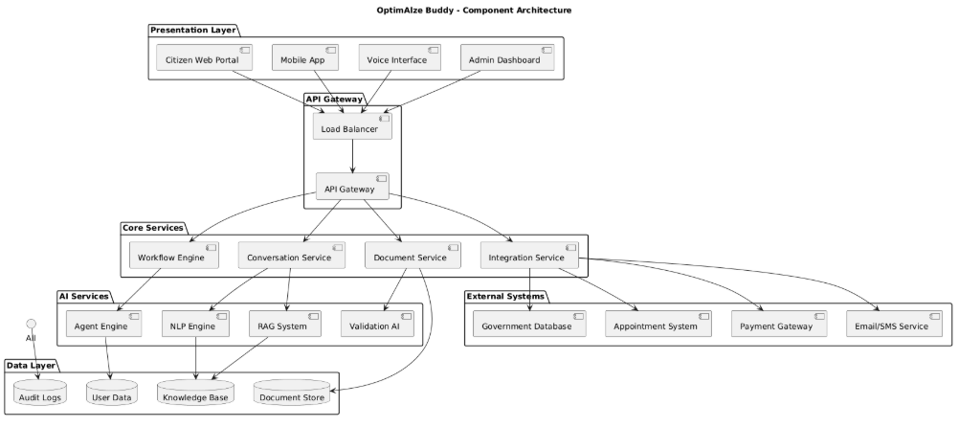
A.2 Data Flow Diagram (Level 1):
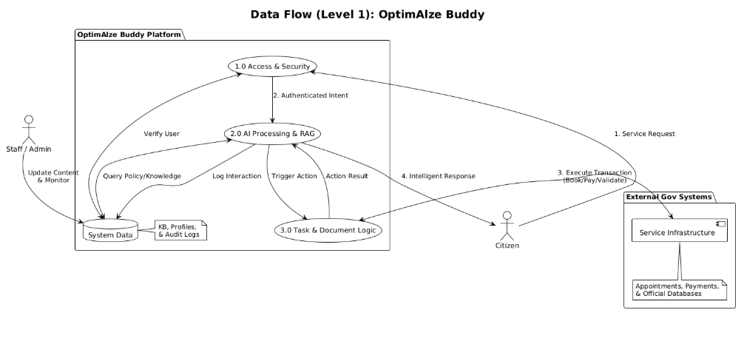
A.3 Use Case Diagram:
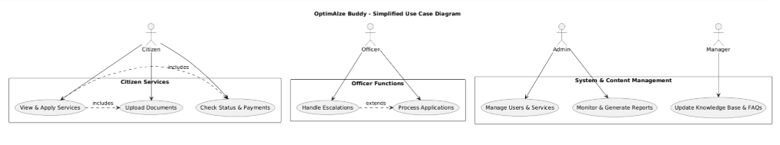
Appendix B: Government Service Categories
Table: Initial Service Coverage
Service Category | Example Services | Complexity Level | Automation Priority
Information Services | Office hours, requirements, FAQs | Low | High
Document Requests | Certificates, permits, copies | Medium | High
Appointment Booking | Service appointments, consultations | Low | High
Form Assistance | Application forms, declarations | Medium | High
Status Inquiries | Application status, processing times | Low | High
Complaint Submission | Service complaints, feedback | High | Medium
Payment Processing | Fee payments, fines, taxes | Medium | Low
Complex Applications | Licenses, permits, benefits | High | Low
Appendix C: Document Validation Standards
Table: Document Quality Requirements
Document Type | Minimum Resolution | Accepted Formats | Validation Criteria
Identification | 300 DPI | PDF, JPG, PNG | Clear photo, all corners visible, readable text
Proof of Address | 200 DPI | PDF, JPG, PNG | Recent date, full document, official letterhead
Certificates | 300 DPI | PDF | Seal/signature visible, no alterations
Application Forms | 150 DPI | PDF, DOC | All fields completed, signatures present
Financial Documents | 200 DPI | PDF, JPG | Account numbers obscured except last 4 digits
Appendix D: Revision History
Table: Document Revision History
Version | Date | Author | Description of Change | Approval Status
1.0 | 2025-10-26 | [Your Name] | Final approved version | Approved
0.9 | 2025-10-20 | [Team Member] | Incorporated security review feedback | Security Review
0.8 | 2025-10-15 | [Team Member] | Added compliance requirements | Compliance Review
0.7 | 2025-10-10 | [Team Member] | Initial complete draft | Stakeholder Review
Approval Signatures:
Government Project Sponsor: ________________________ Date: __________
Technical Architecture Lead: ________________________ Date: __________
Security Compliance Officer: _______________________ Date: __________
Citizen Experience Representative: __________________ Date: __________
Legal Department: ________________________________ Date: __________

